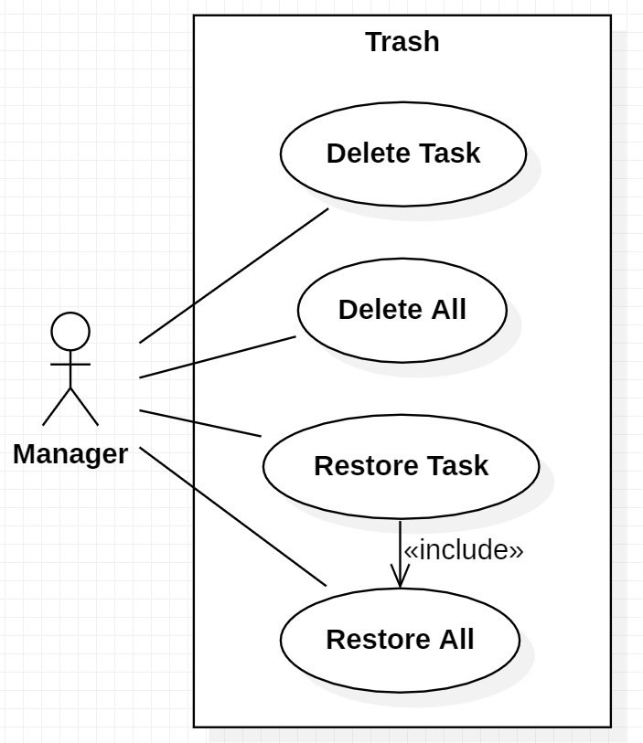**Trash Use Case**

Delete Task

Pre-condition: At least one task must exist in the trash and at least one task must be selected.

The use case starts when the Manager clicks the delete button in the trash menu.

The selected task is deleted permanently.

Pos-condition: None

Primary Actors:

• Manager.

Secondary Actors:

• None.

Delete All

Pre-condition: At least one task must exist in the trash.

The use case starts when the Manager clicks the delete all button in the trash menu.

All the tasks present in the trash are permanently deleted.

Pos-condition: None

Primary Actors:

• Manager.

Secondary Actors:

• None.

Restore Task

Pre-condition: At least one task must exist in the trash and at least one task must be selected.

The use case starts when the Manager clicks the restore button in the trash menu.

The selected task is restored, with some of its properties, to the task list.

Pos-condition: None

Primary Actors:

• Manager.

Secondary Actors:

• None.

Restore All

Pre-condition: At least one task must exist in the trash.

The use case starts when the Manager clicks the restore all button in the trash menu.

All the tasks present in the trash are restored, with some of its properties, to the task list.

Pos-condition: None

Primary Actors:

• Manager.

Secondary Actors:

• None.